Recuva

[Data Deletion and Recovery Using Recuva]

Submitted By:

September 17, 2024

**1. What You Did:**

Download Link- https://[www.ccleaner.com/recuva/download](http://www.ccleaner.com/recuva/download)

I visited the official Recuva download page at [Recuva Download](https://www.ccleaner.com/recuva/download) and installed the free version. The installation process was straightforward, and the software was ready to use.

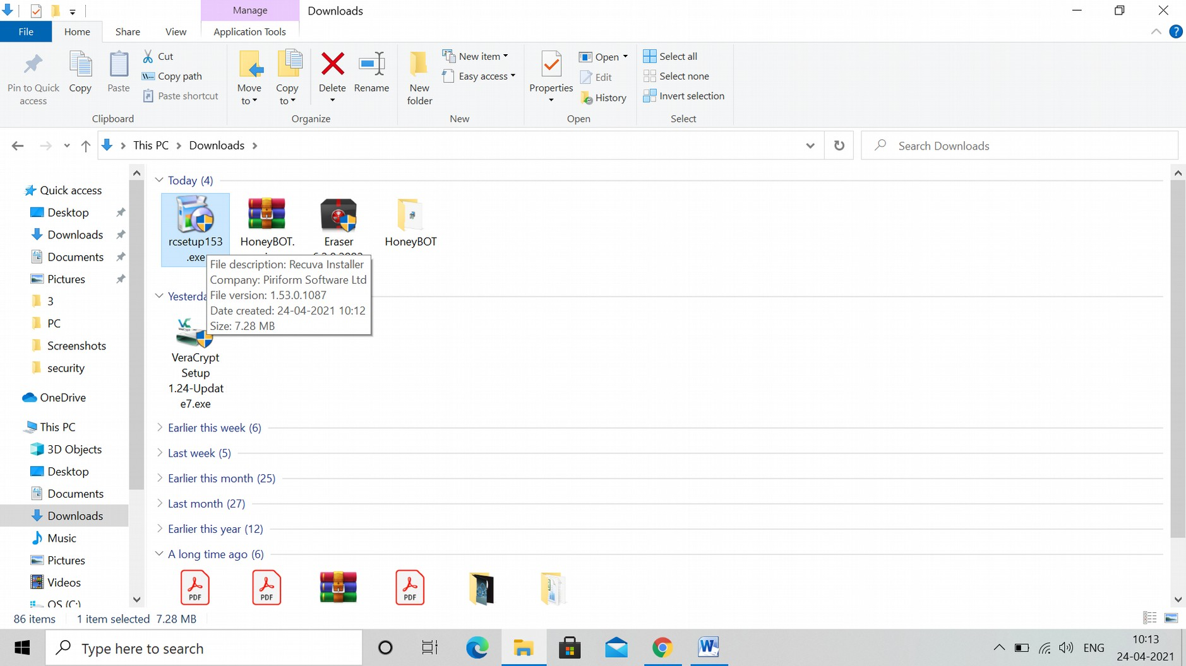

# Installation:

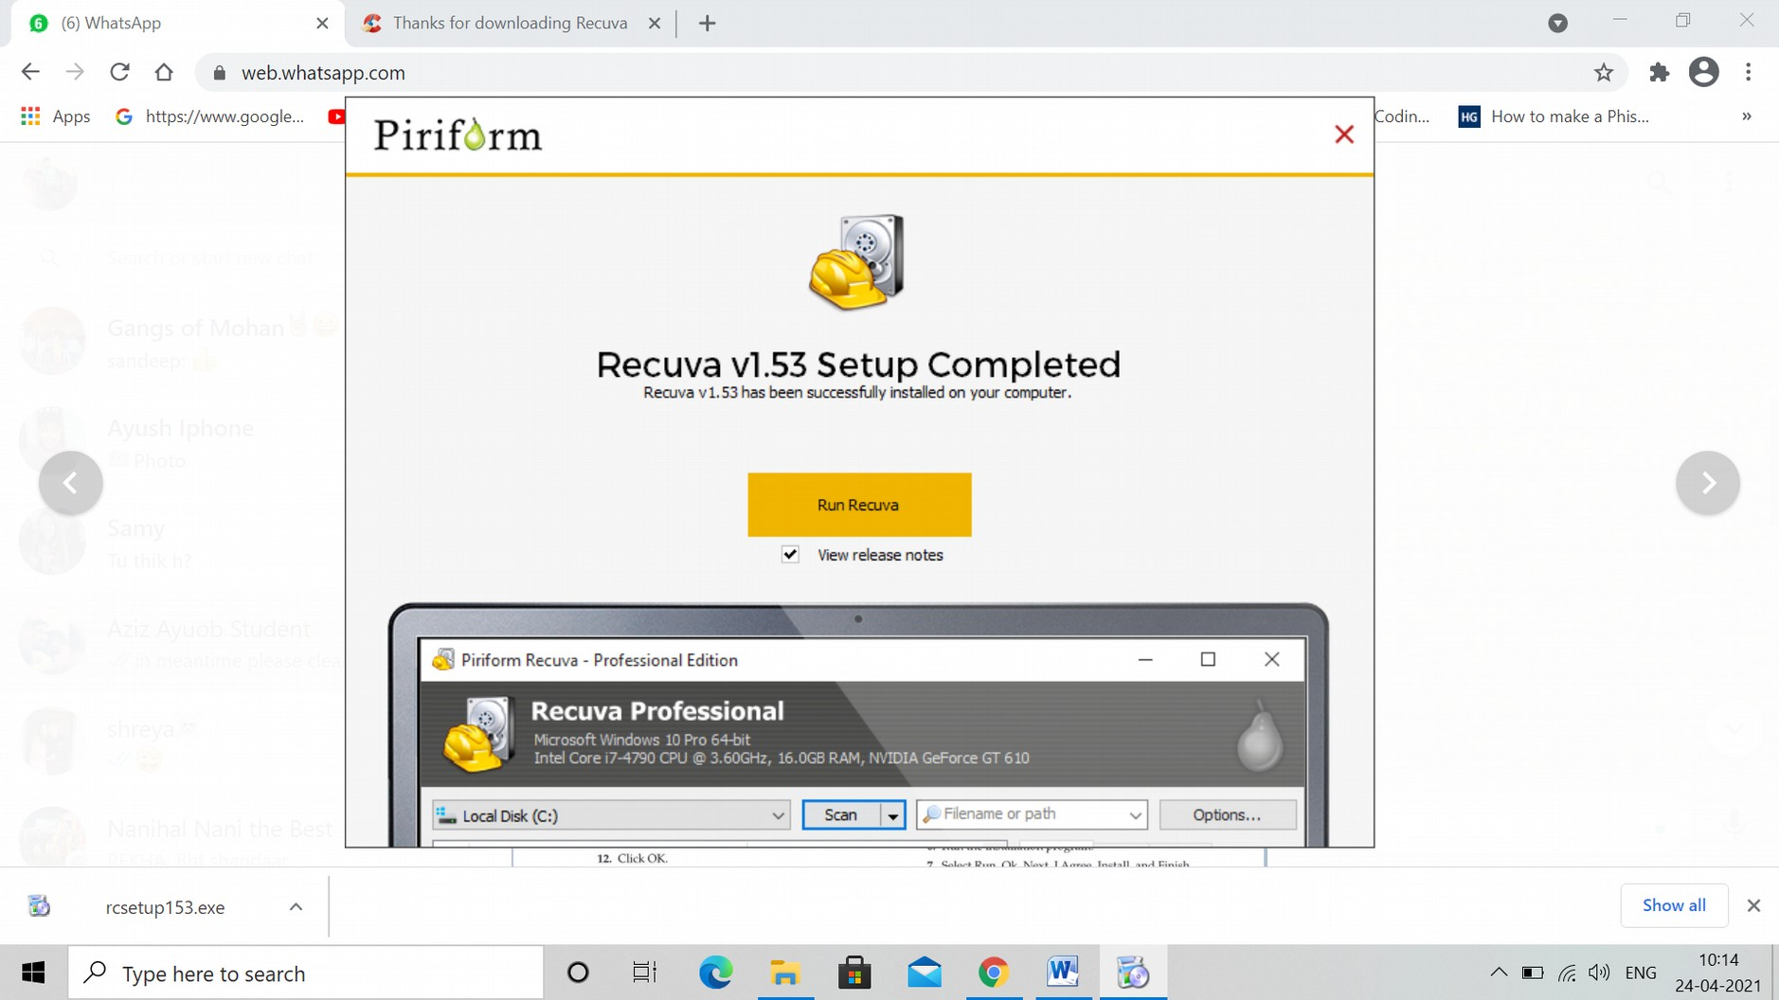

# Download Sample File:

# I obtained the "Dilbert\_Security.gif" file from the course materials, ensuring that it was correctly downloaded and ready for the experiment.

# C:\Users\Prime Com\Desktop\Dilbert_secuirity.gif

# Delete and Restore File:

# I deleted the "Dilbert\_Security.gif" file by moving it to the recycle bin. I then restored the file from the recycle bin and confirmed it opened properly without any issues.

# 

# Permanently Delete File

# I deleted the file again, and this time I permanently removed it by emptying the recycle bin. This ensured that the file was no longer accessible via regular system methods.

# C:\Users\Prime Com\Desktop\deleted files.jpg

Selecting which drive/folder to look for

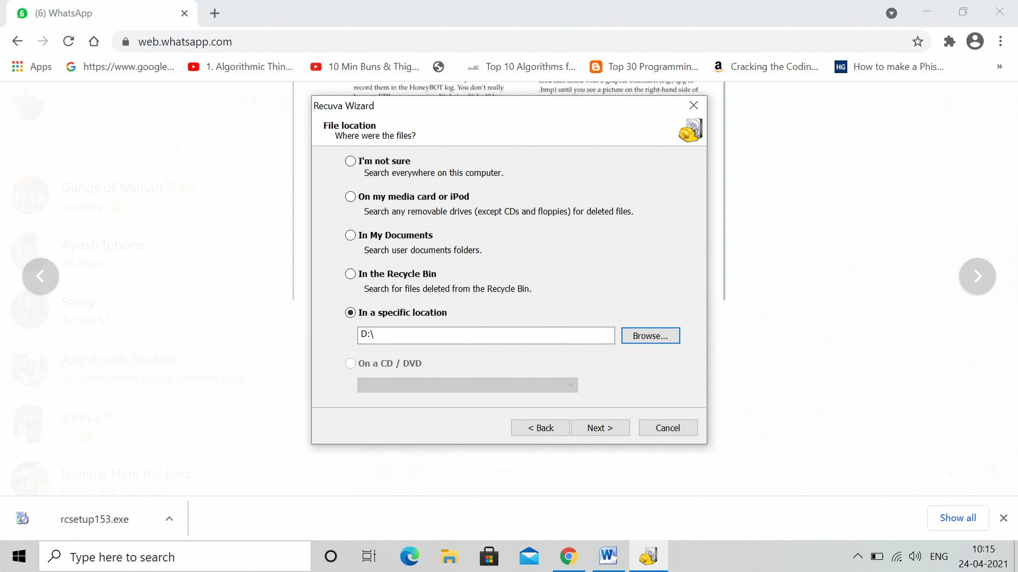

Scan Results:

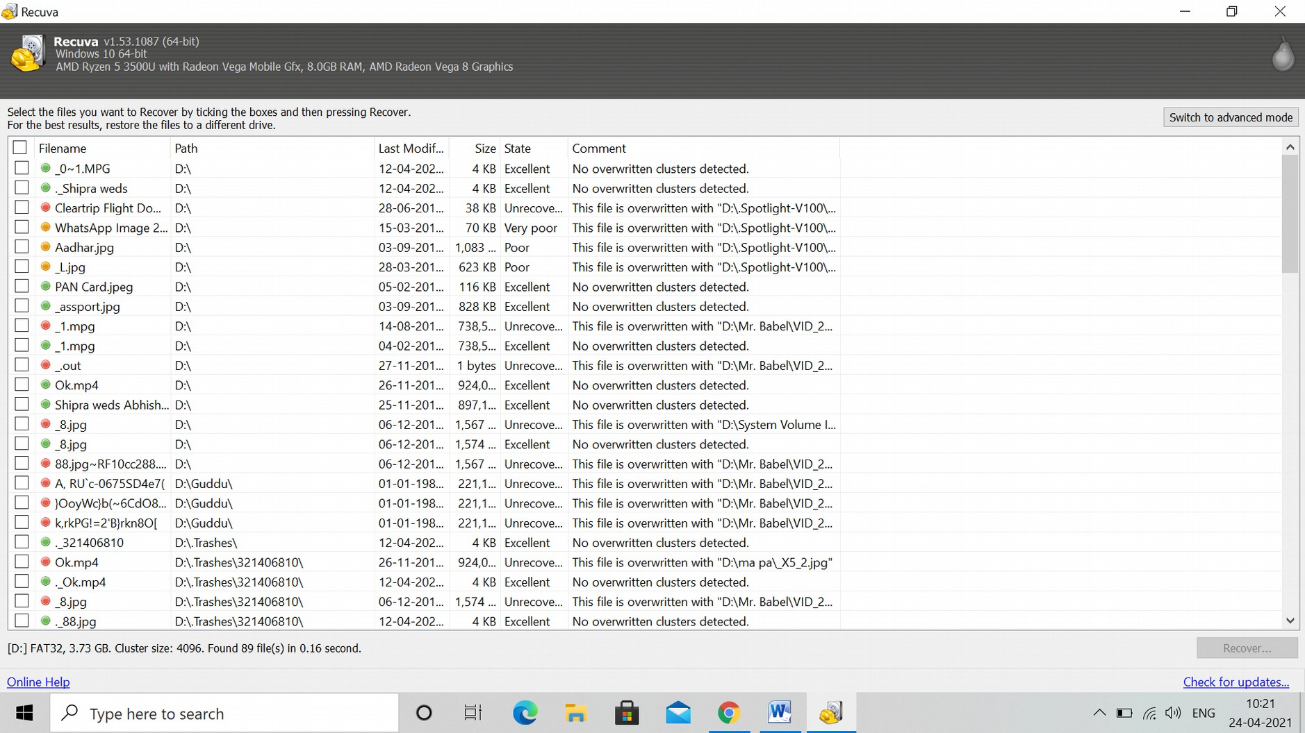

Recovering the files:

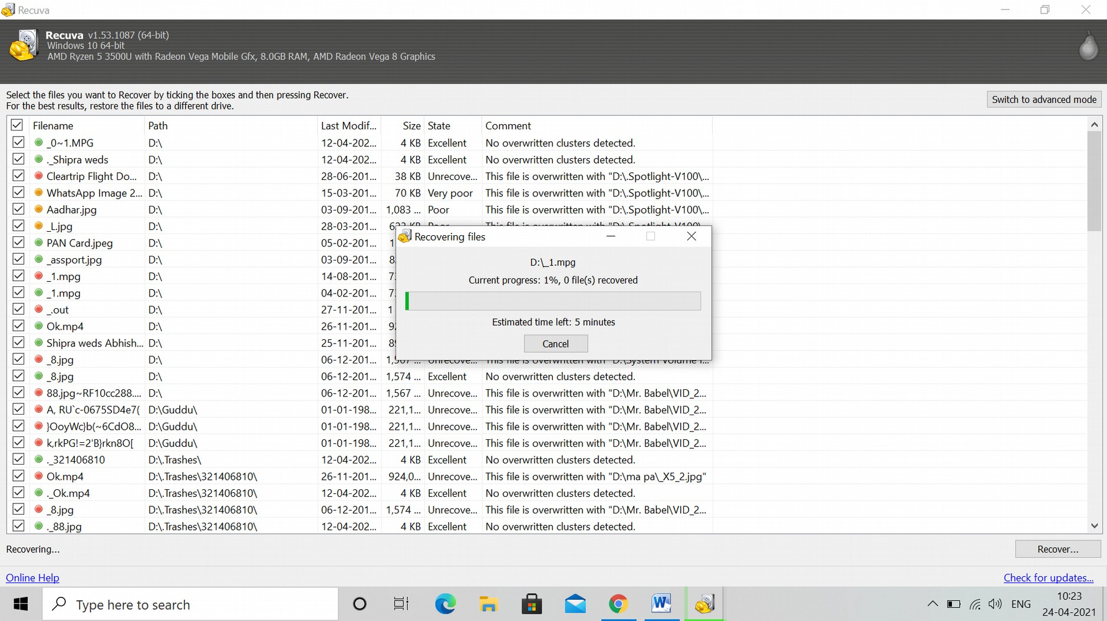

# Recovered Files:

# C:\Users\Prime Com\Desktop\Screenshot_2.jpg

**2. What Are the Results?**

# Recovered Dilbert\_Security.gif:

# 

# Download CCleaner (Optional): <https://www.ccleaner.com/download>

# 

# Run CCleaner

# C:\Users\Prime Com\Desktop\Screenshot_1.jpg

### **3. What You Learned:**

* **How Files Are Stored:**
* Files are stored on hard drives in clusters, with the operating system maintaining a reference to those clusters. When a file is deleted, the file system marks the clusters as available for overwriting, but the data remains until it is overwritten.
* **What Happens When You "Delete" a File:**
* Deleting a file simply removes the reference to the data in the file system and moves it to the recycle bin. Even after emptying the recycle bin, the data still exists on the hard drive until new data overwrites it.
* **How Recuva Recovers Files:**
* Recuva works by scanning the hard drive for data that has been "deleted" but not overwritten. It can recover files because they still exist in the storage sectors, even after being removed from the file system.
* **How CCleaner Permanently Deletes Files:**
* CCleaner permanently deletes files by overwriting the sectors of the hard drive where the data was stored, ensuring that the data is no longer recoverable. This process is critical when dealing with sensitive information that must be permanently erased.

### **Additional Thoughts:**

This exercise clearly demonstrated that deleted files can still be recovered, even after they are permanently removed from the recycle bin, using tools like Recuva. While Recuva could retrieve "Dilbert\_Security.gif," it also highlighted the need for specialized software, such as CCleaner, to ensure that sensitive data is securely erased and cannot be recovered. This is particularly important in scenarios where privacy and data security are essential.